For a real symmetric matrix A, A, there exists a singular value decomposition as A=USU', and S should be a rectangular diagonal matrix with nonnegative real numbers on the diagonal.

As we know, for a real symmetric matrix A, there exists a symmetrical singular value decomposition as  
A=USU',  
where U is an orthogonal matrix.

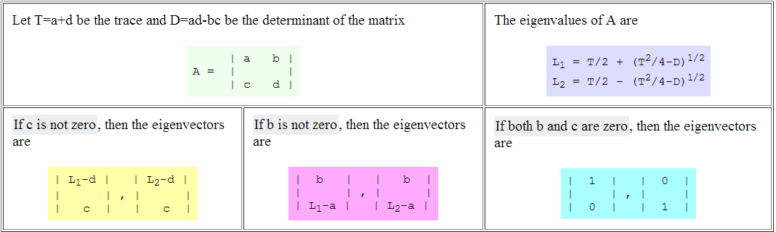

**covariance matrix** is always both **symmetric** and positive semi- definite(non-negative definite).

